

**announced**

**measly**

**advantage**



**dubiously**

**plaintively**

**intently**



**wily**

**“in spite of”**

**sympathetic**

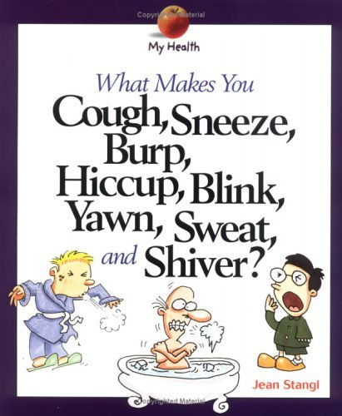

**temporarily**

**involuntary**

**contagious**